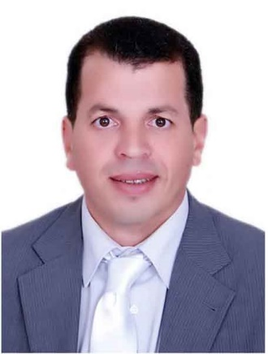
5 - سيرة ذاتية مختصرة لرئيس الشعبة:
Prof. Dr. Adel Shalaby is currently employed as a Professor and the Head of Environmental studies division at the National Authority of Remote Sensing and Space Science (NARSS). He graduated from Al-Azhar University, faculty of agriculture in 1995, and then received an MSc in physical land resources, ITC, university of Ghent in 1999). He has got his Ph.D. in soil science and remote sensing from Chiba University, Center of Environmental Remote Sensing in 2007.
He has worked on a number of research projects in Japan and Egypt and joint projects with the European Union. The focus of his present research is on using remote sensing techniques to explore land resources for the purpose of agricultural sustainable development. .
He has authored several publications in international peer-reviewed scientific journals and conferences. He was a member of organizing and scientific committees for international conferences, while he has been active as a reviewer in more than 30 Scopus Index scientific journals. He worked as an expert at the AOAD and cooperative researcher at Chiba University
His field of study focuses on the integration of data from various remote sensing devices, field data and geographic information system for sustainable development and land use planning

